|  |  |  |  |  |  |
| --- | --- | --- | --- | --- | --- |
| Date | 5-Dec-22 | | | Tester Name | Mohammad Yusuf |
| Environment | Penfax - Test | | | Login used |  |
| Operating System | Select OS | Version: | Update: | | |
| Software Used | Select Software | Version: | Update: | | |
| Select Software | Version: | Update: | | |
| Release version |  | | | | |
| Title | M17 Contributions & DCT | | | | |
| Test Type | Regression | | | | |
| Test Scenario | M17.03 Copy a file and post | | | | |
|  |  | | | | |
| Expected Results | Old file details should be copied to the new file.  Processed contributions should be shown under Payroll History and Contribution History.  Accounting should be verified in General Ledger. | | | | |
| Pass/Fail | Pass | | | JIRA# | N/A |

Describe your steps with screenshots:

1. Log into MEPP DCT and select the Employer from the dropdown.

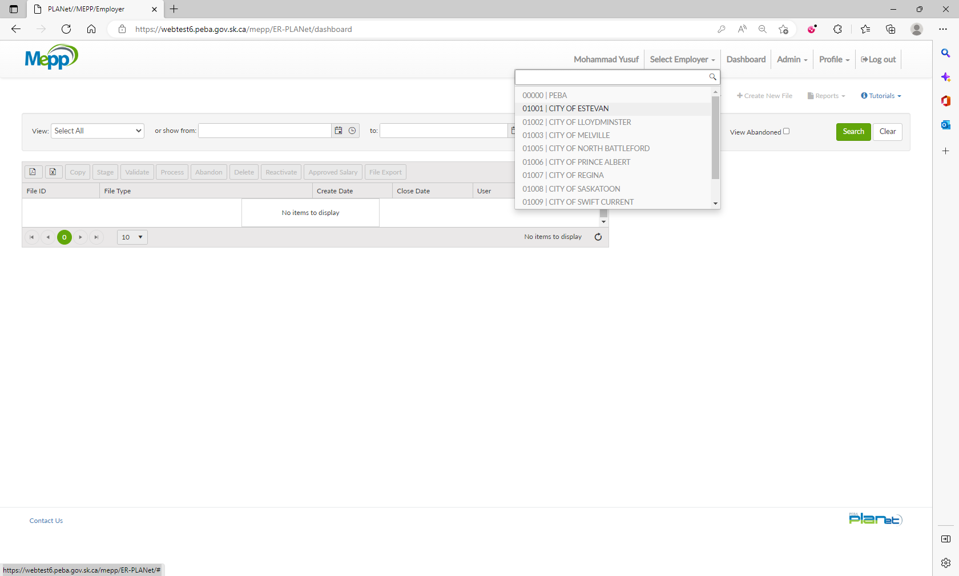

1. Note down File Details of an existing file.

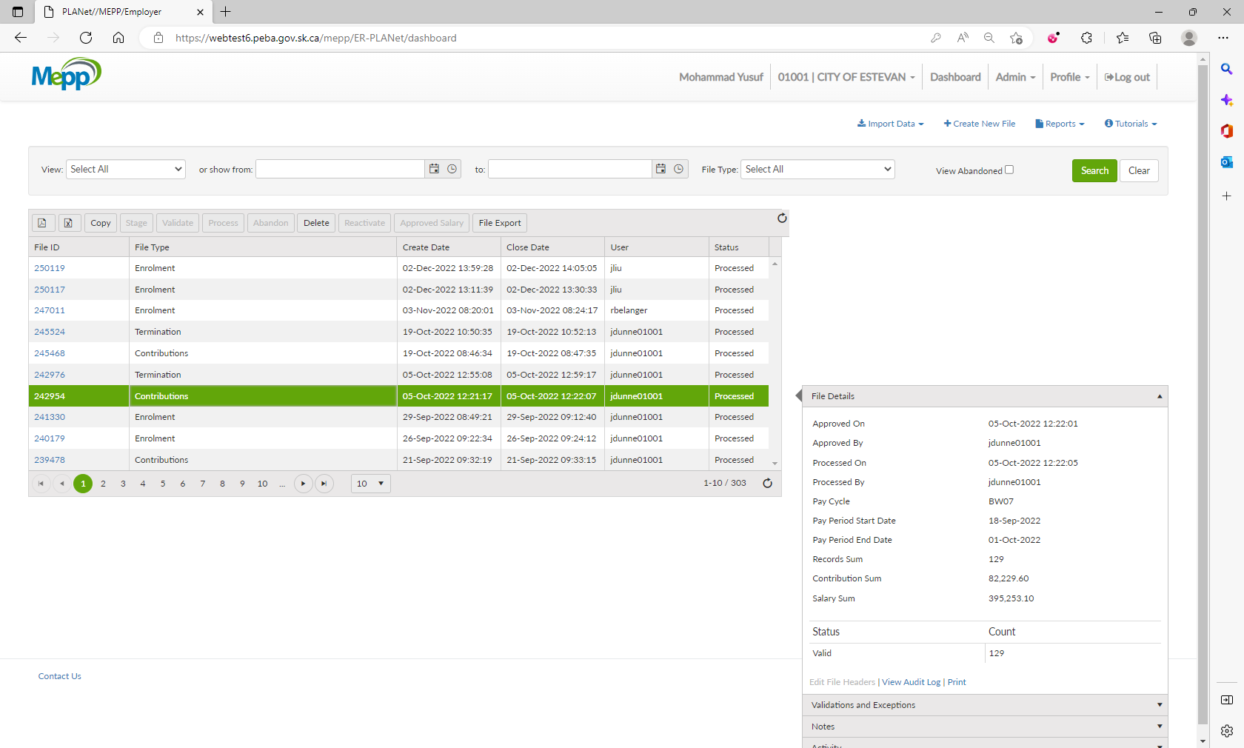

1. Click on Copy.

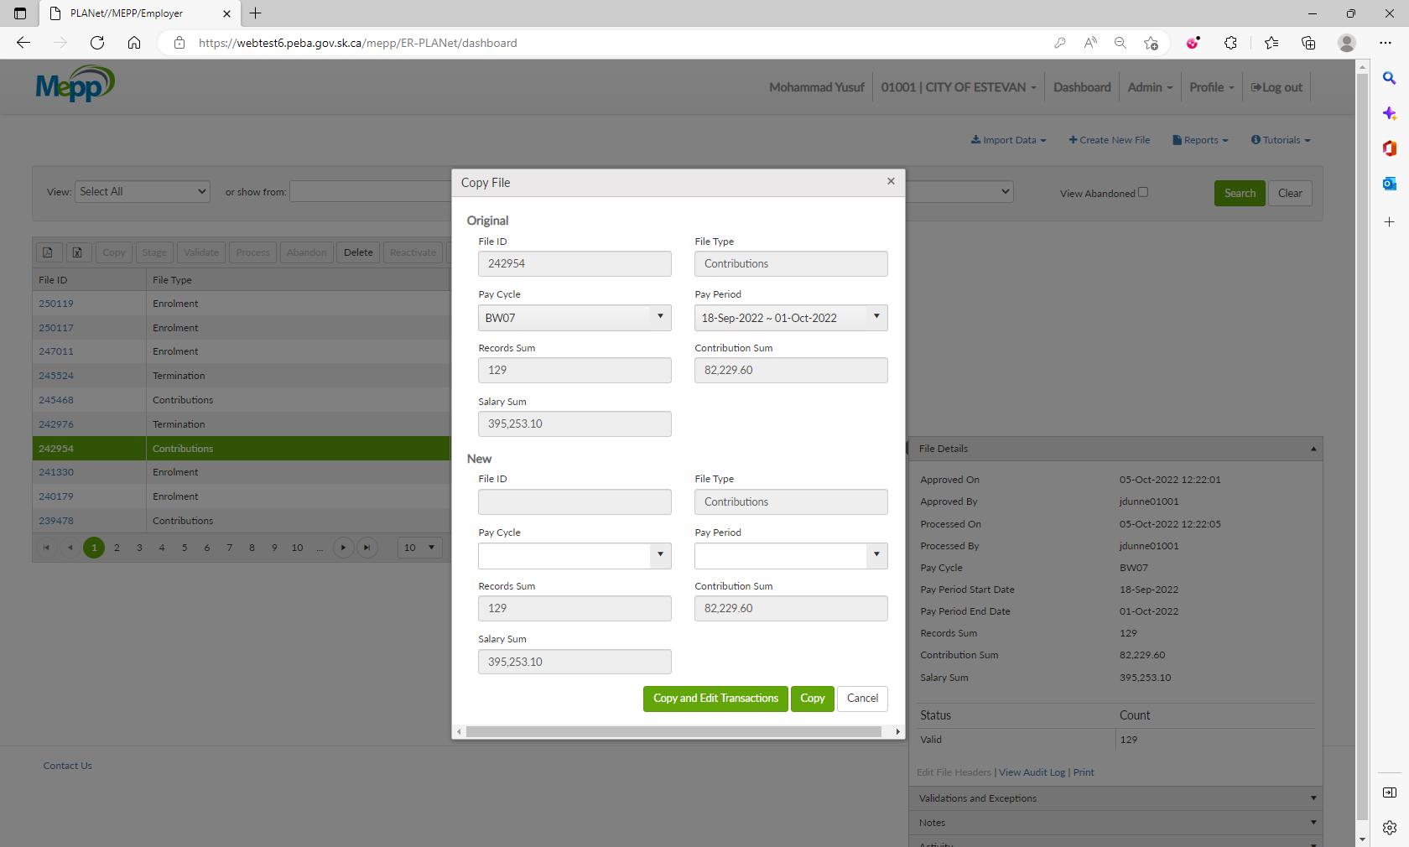

1. In the next window, you need to enter Pay Cycle and Pay Period.

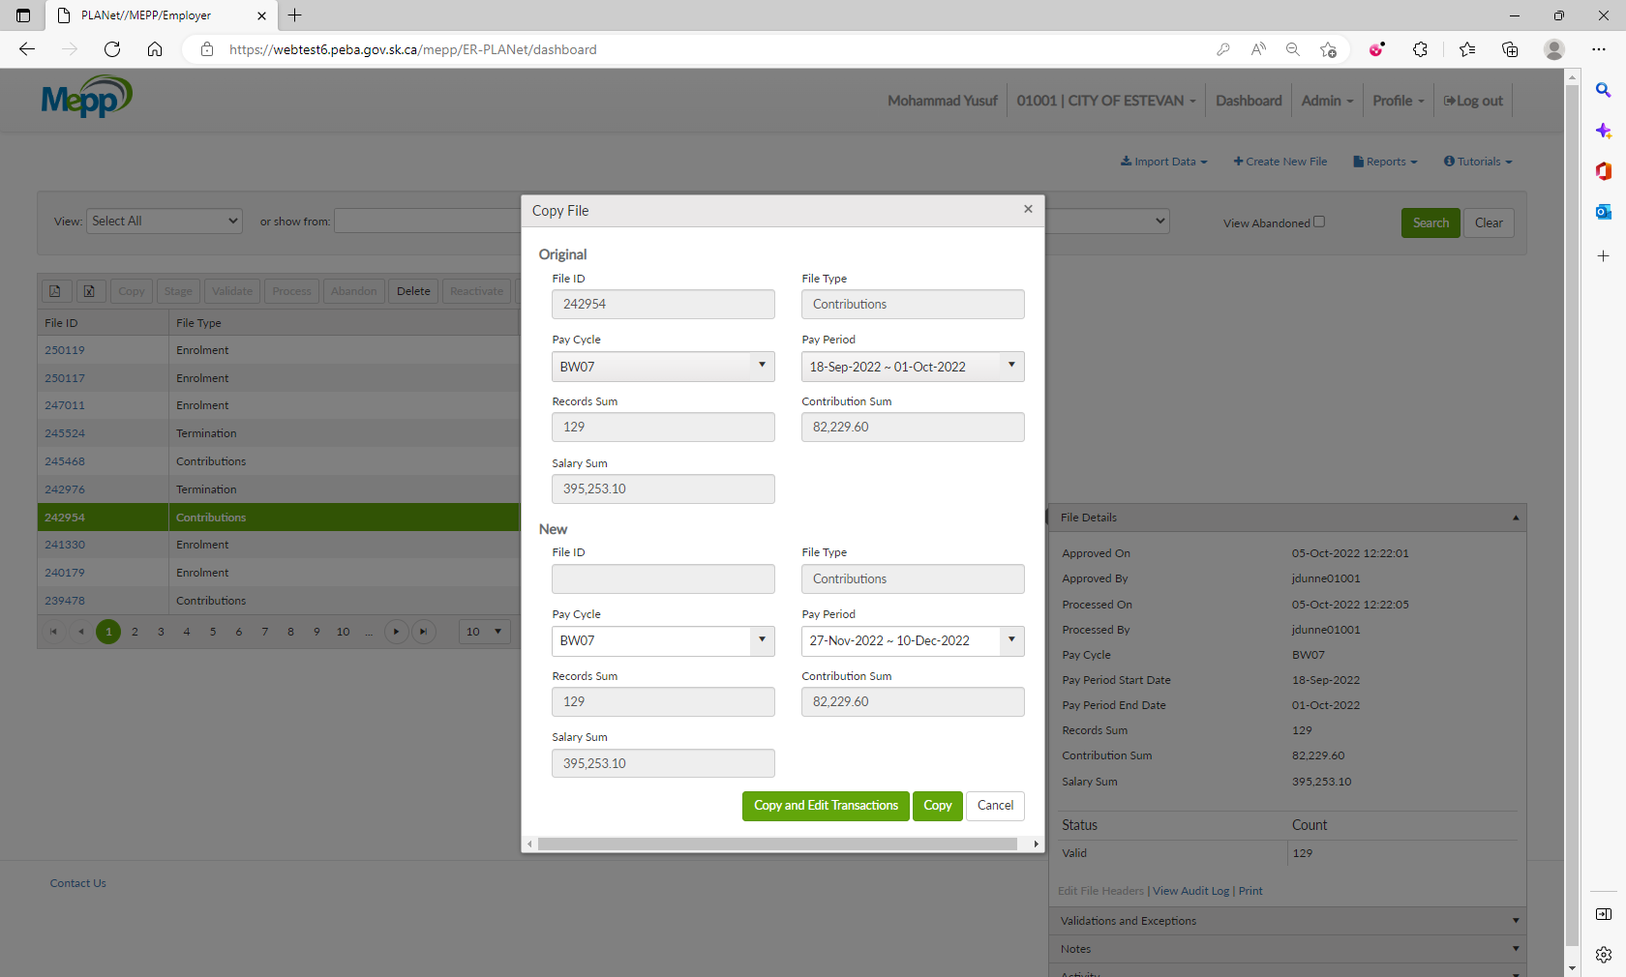

1. If you want to edit the transactions, click on Copy and Edit Transactions or click on Copy.

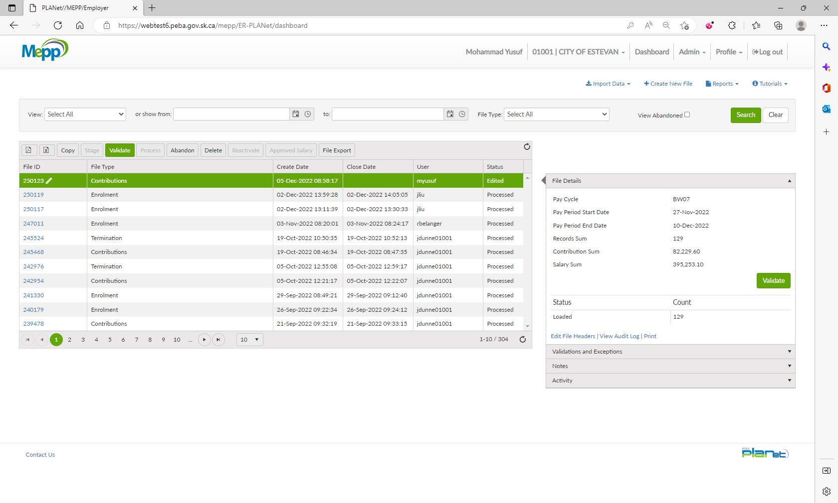

1. Make sure you have a new file created and the File Details are copied from the old file.

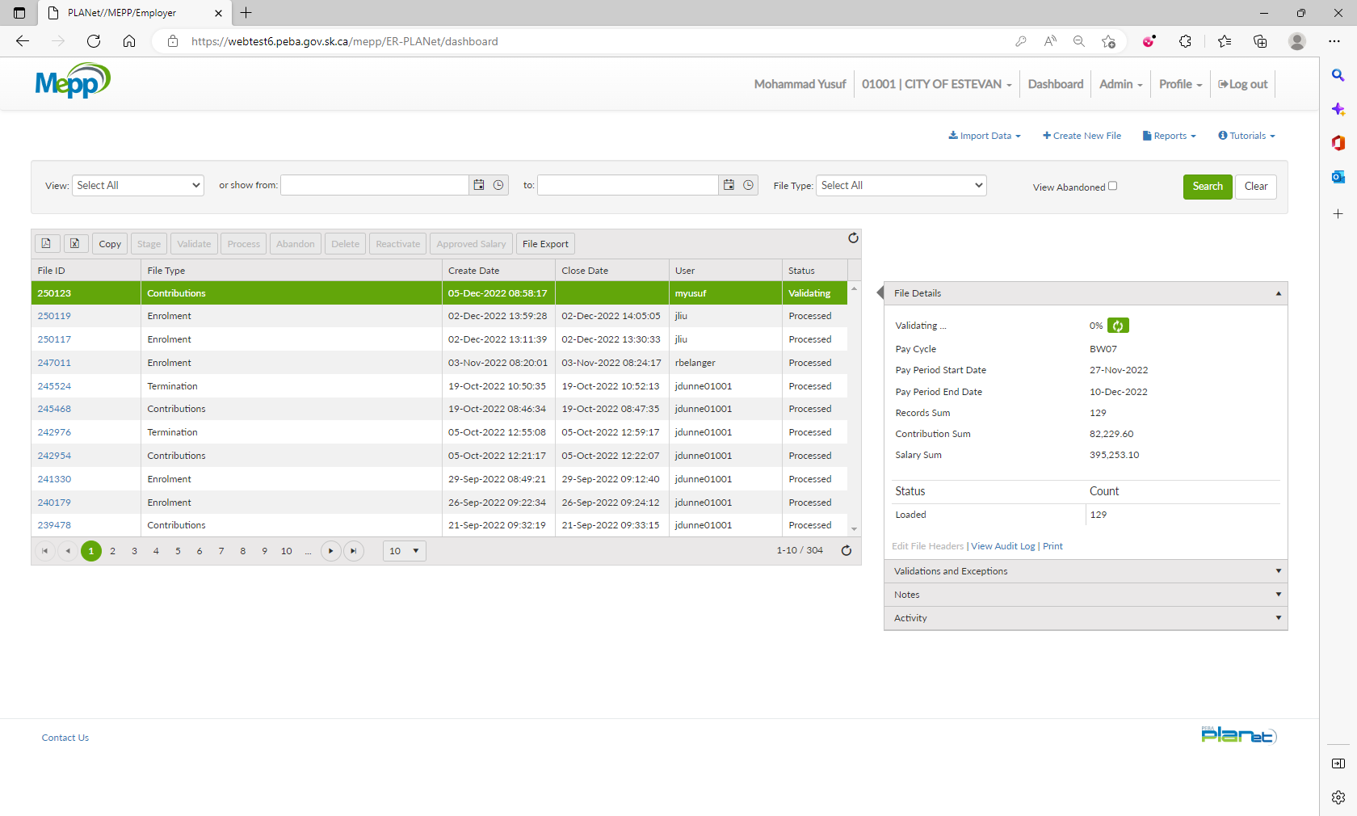

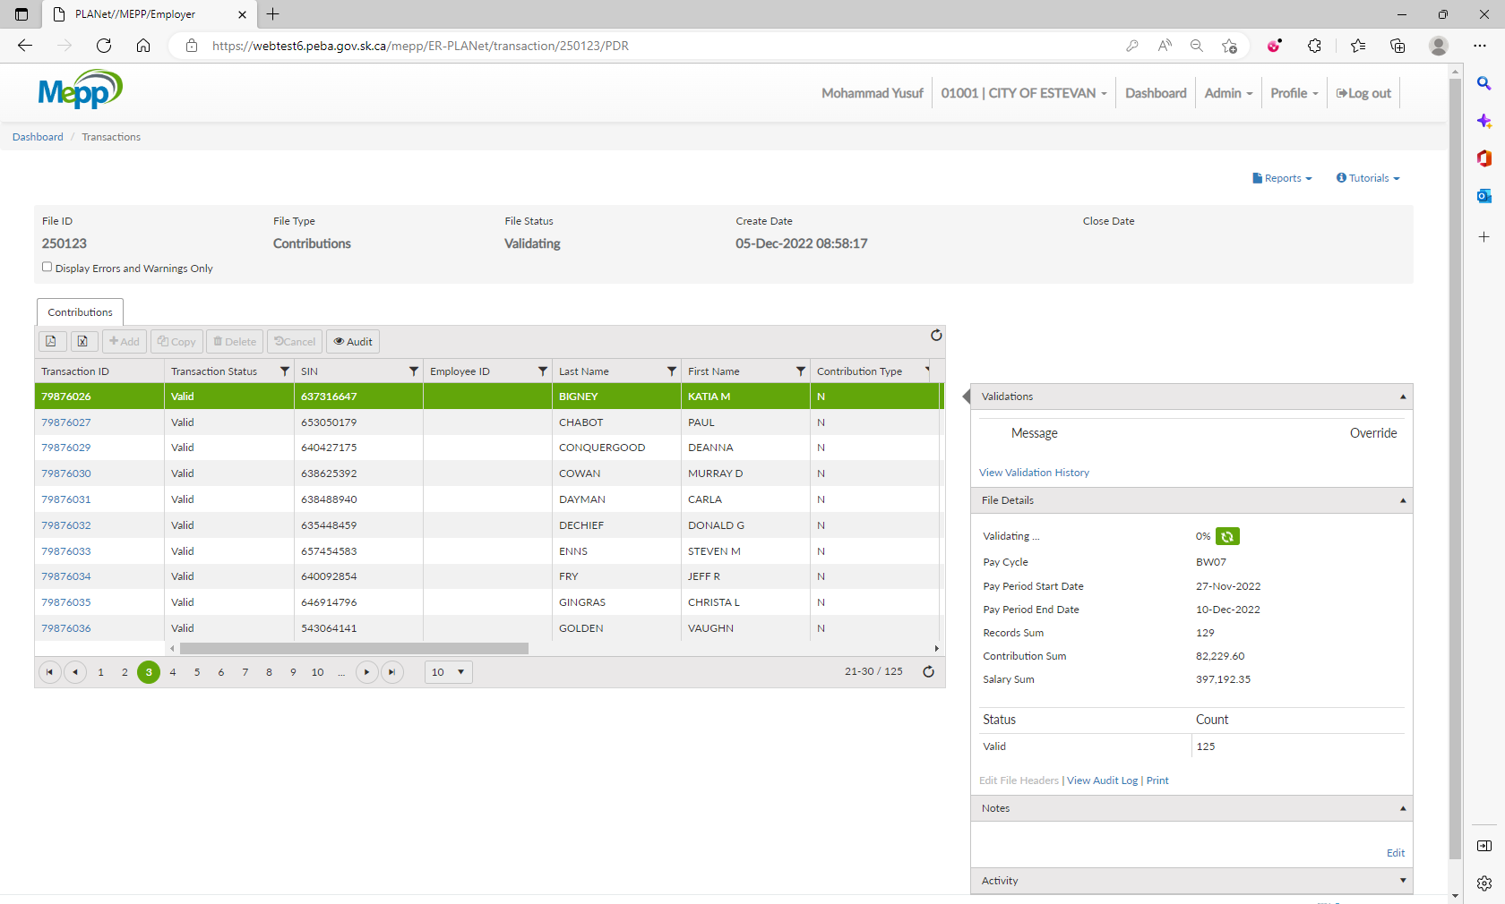

Deleted 4-member details as the contribution date is before the joining date (Error).

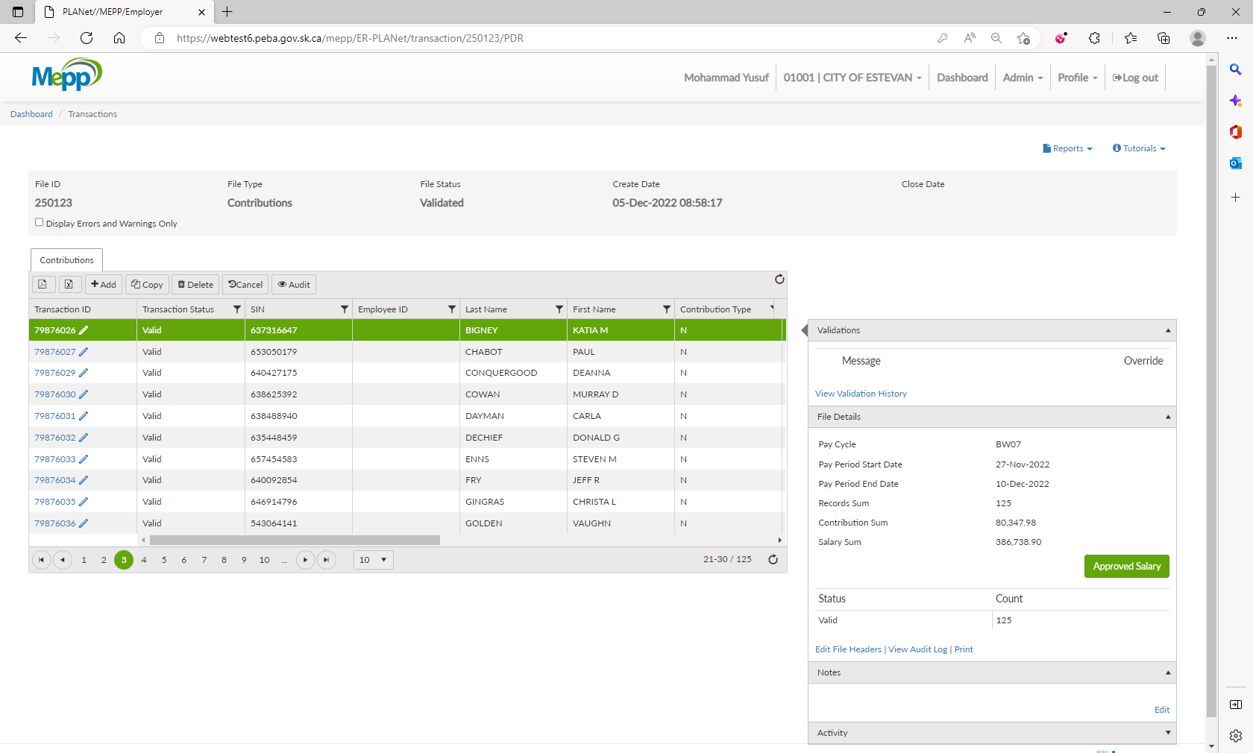

1. Under File Details, click on Validate.

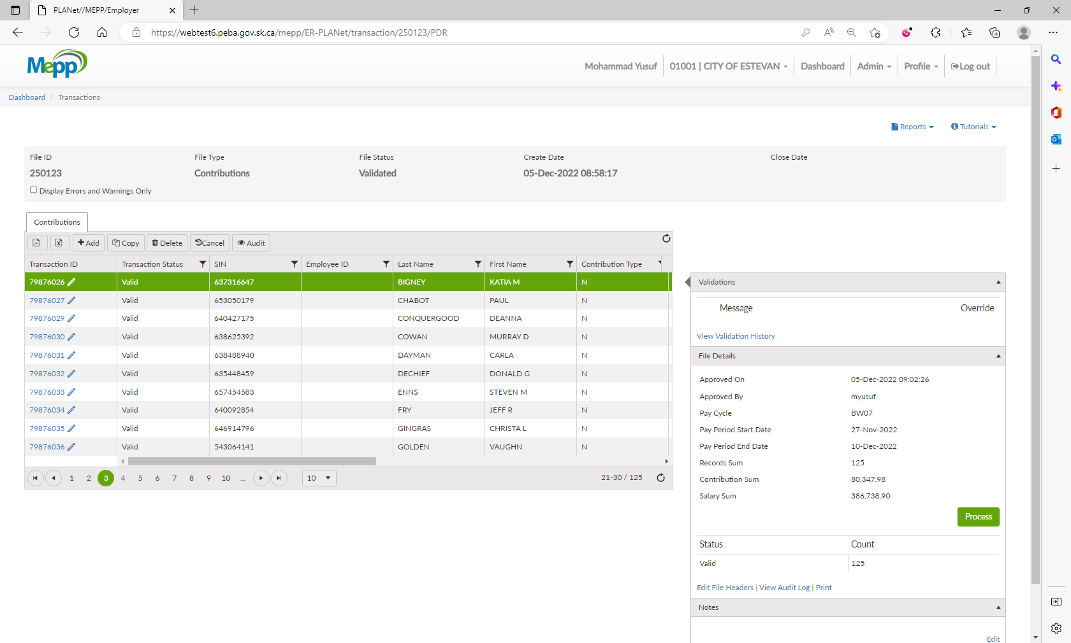

1. Now, all the details available under File Details. Click on Approve Salary.

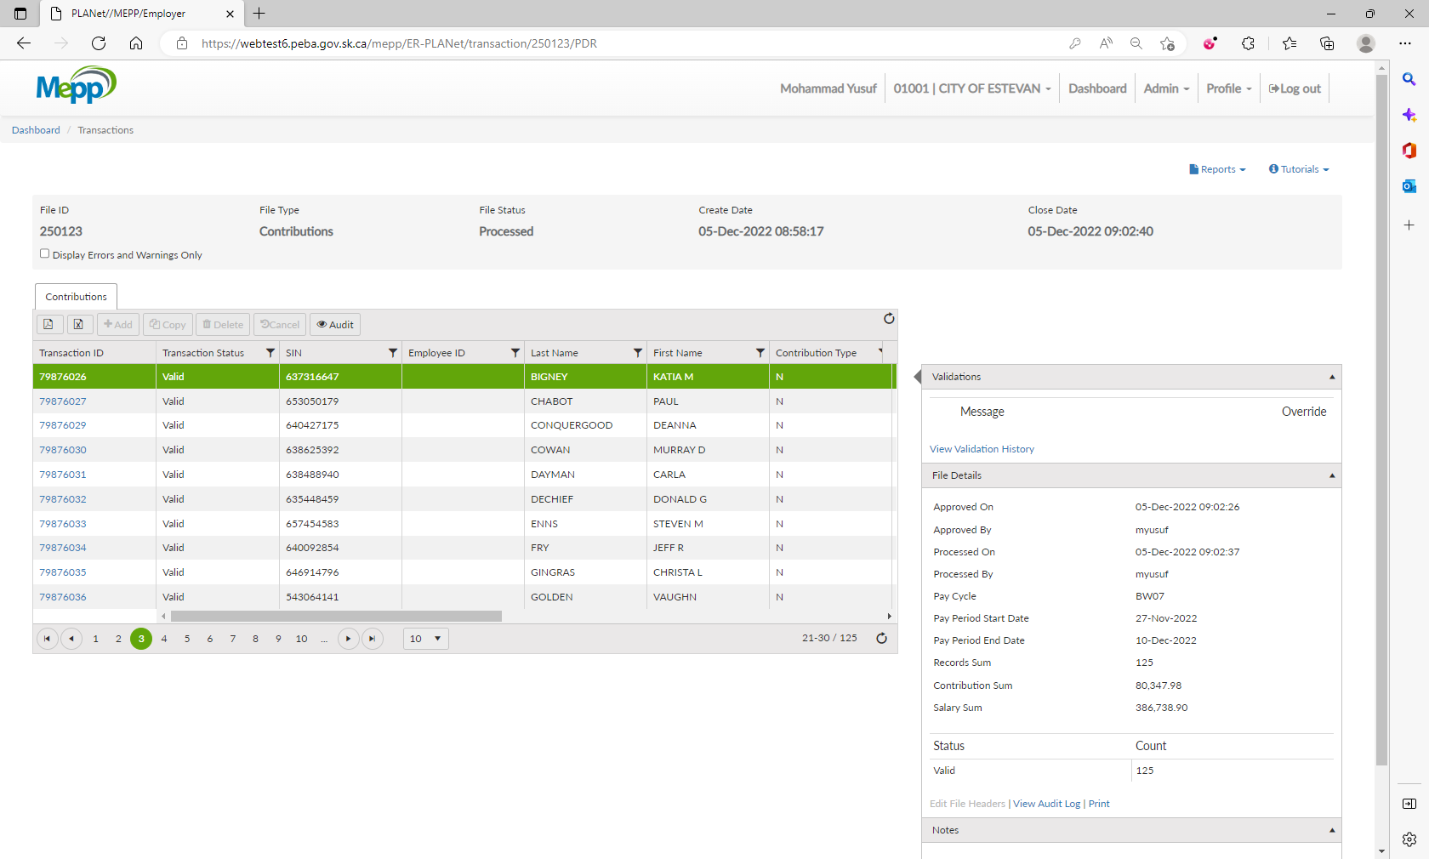

1. Click on Process.



1. File is processed now.

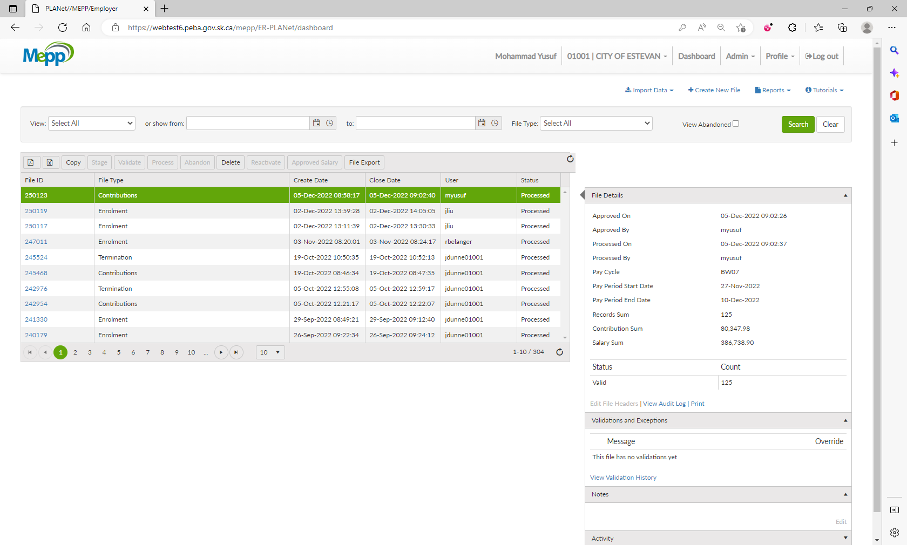

1. Log into Penfax. Click on Batches -> Data Posting Batches. Search with the employer and then click on the batch id you just processed in DCT. Go to Pending Tab. Verify the details in header. 2 validation errors are for remittance.

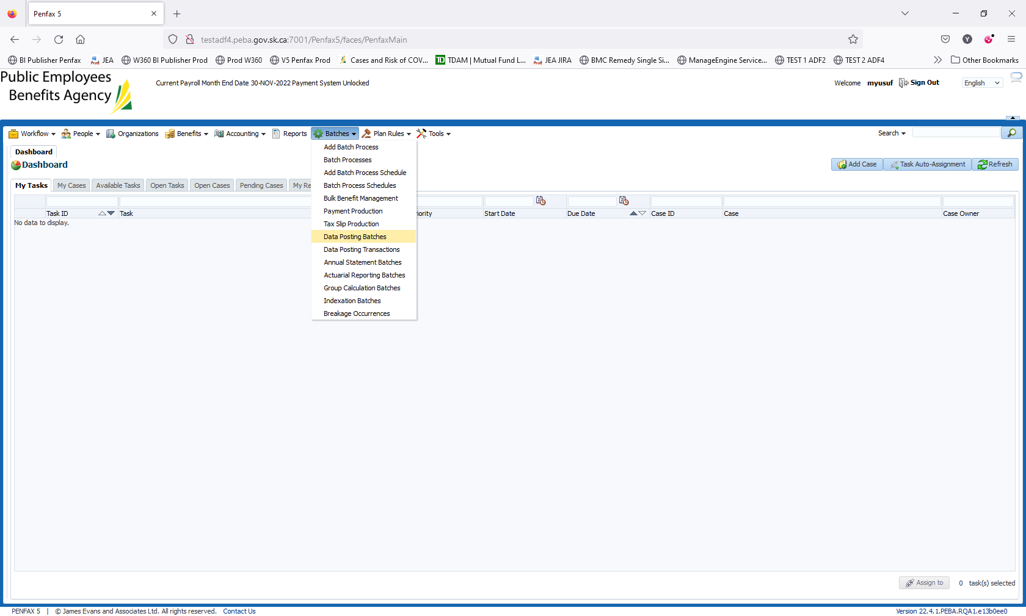

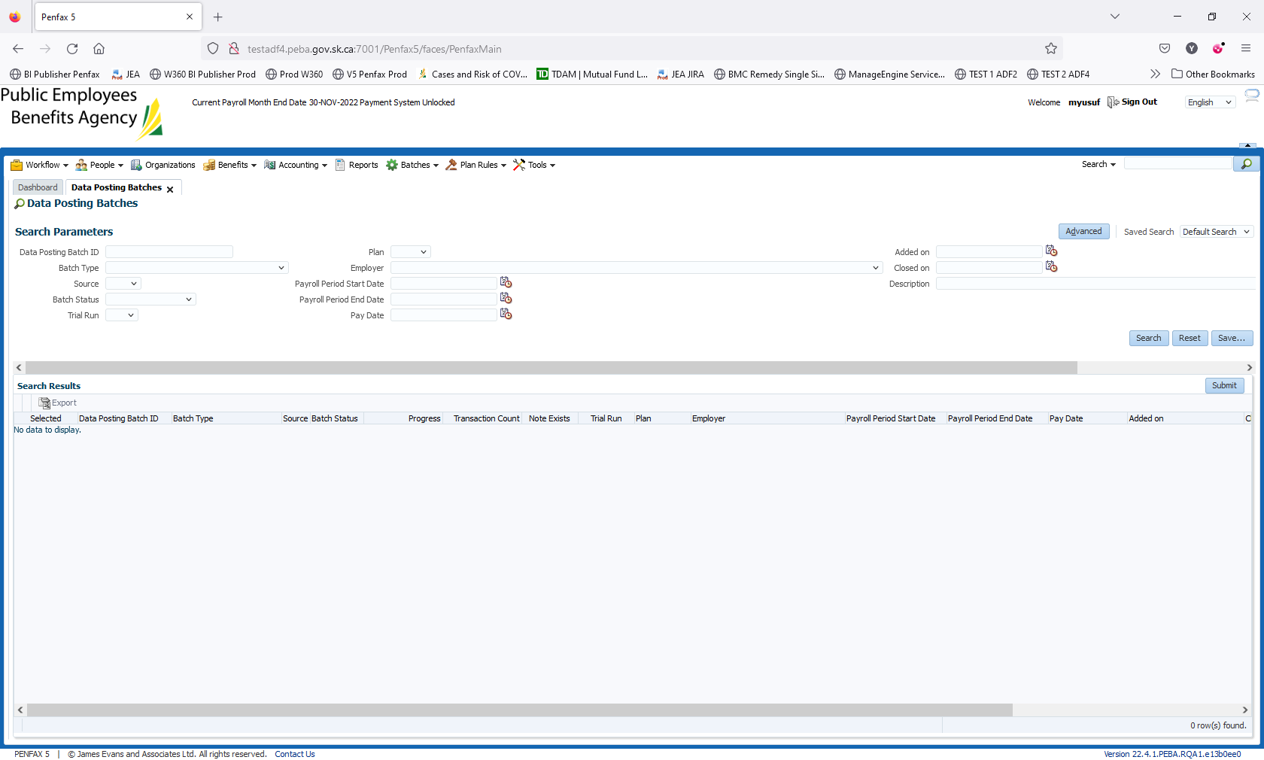

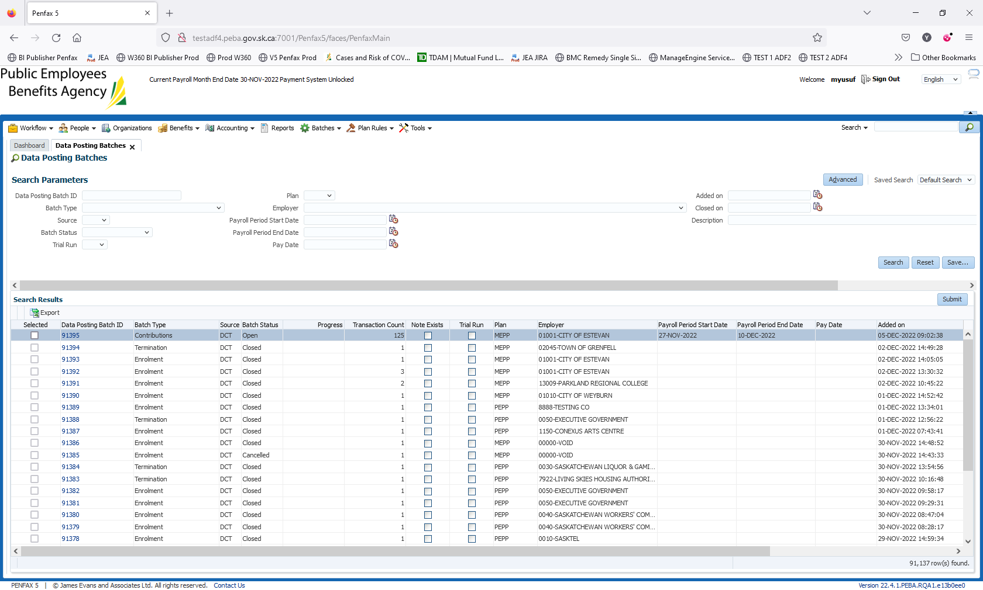

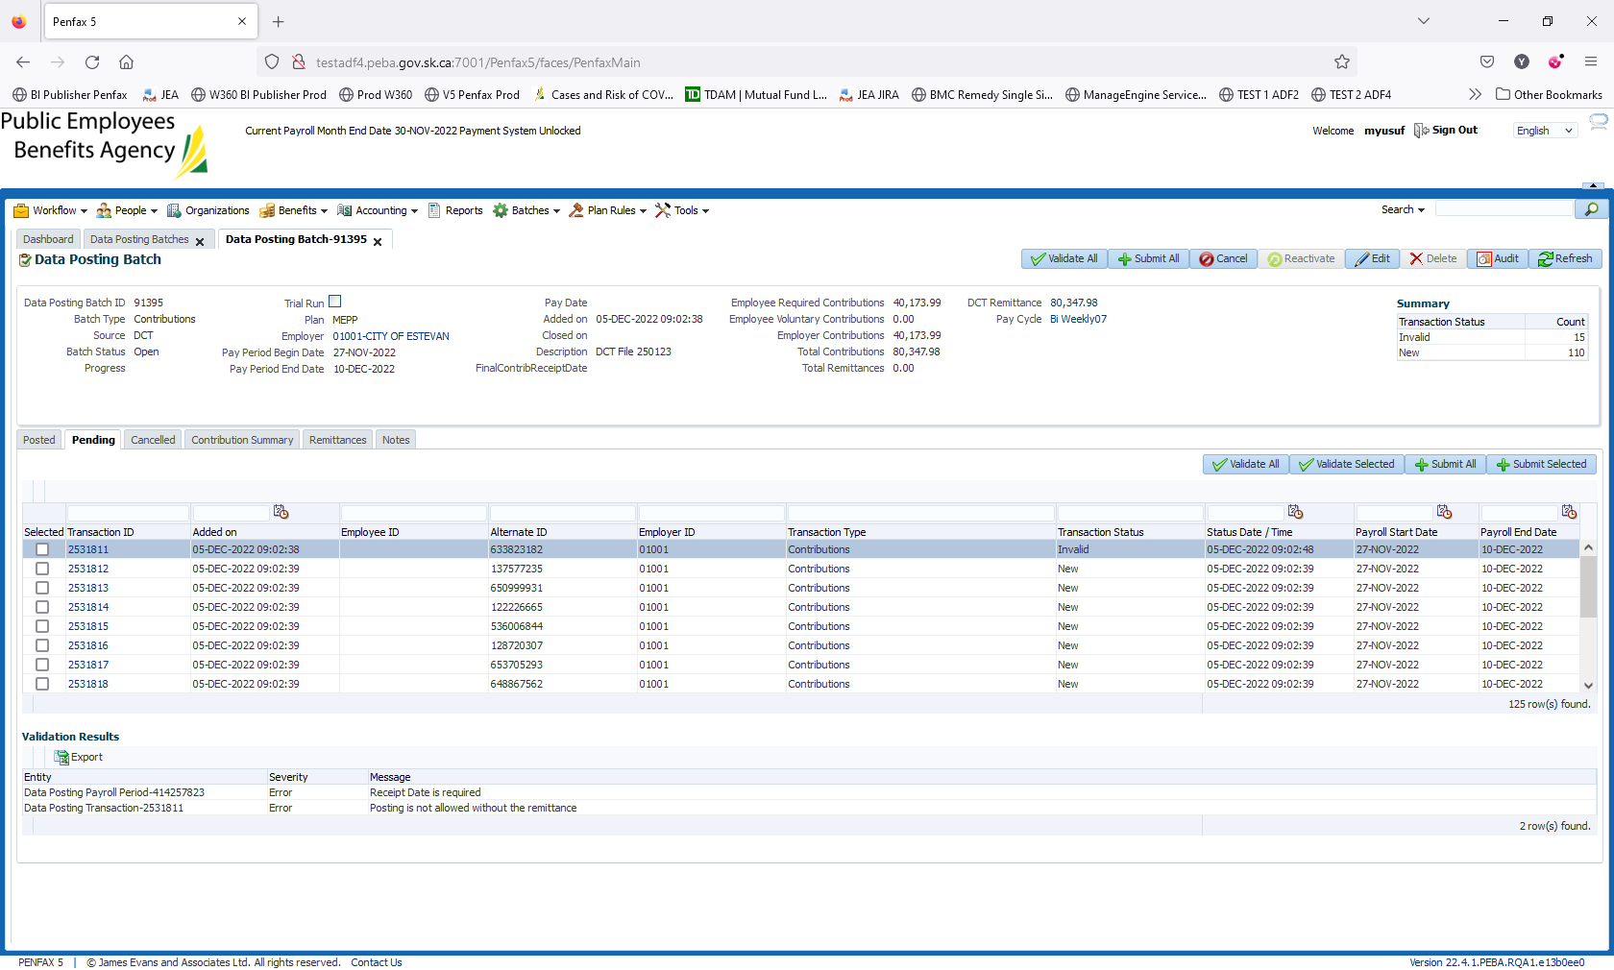

1. To add a new remittance, go to Accounting -> Remittance Management -> Add Remittance

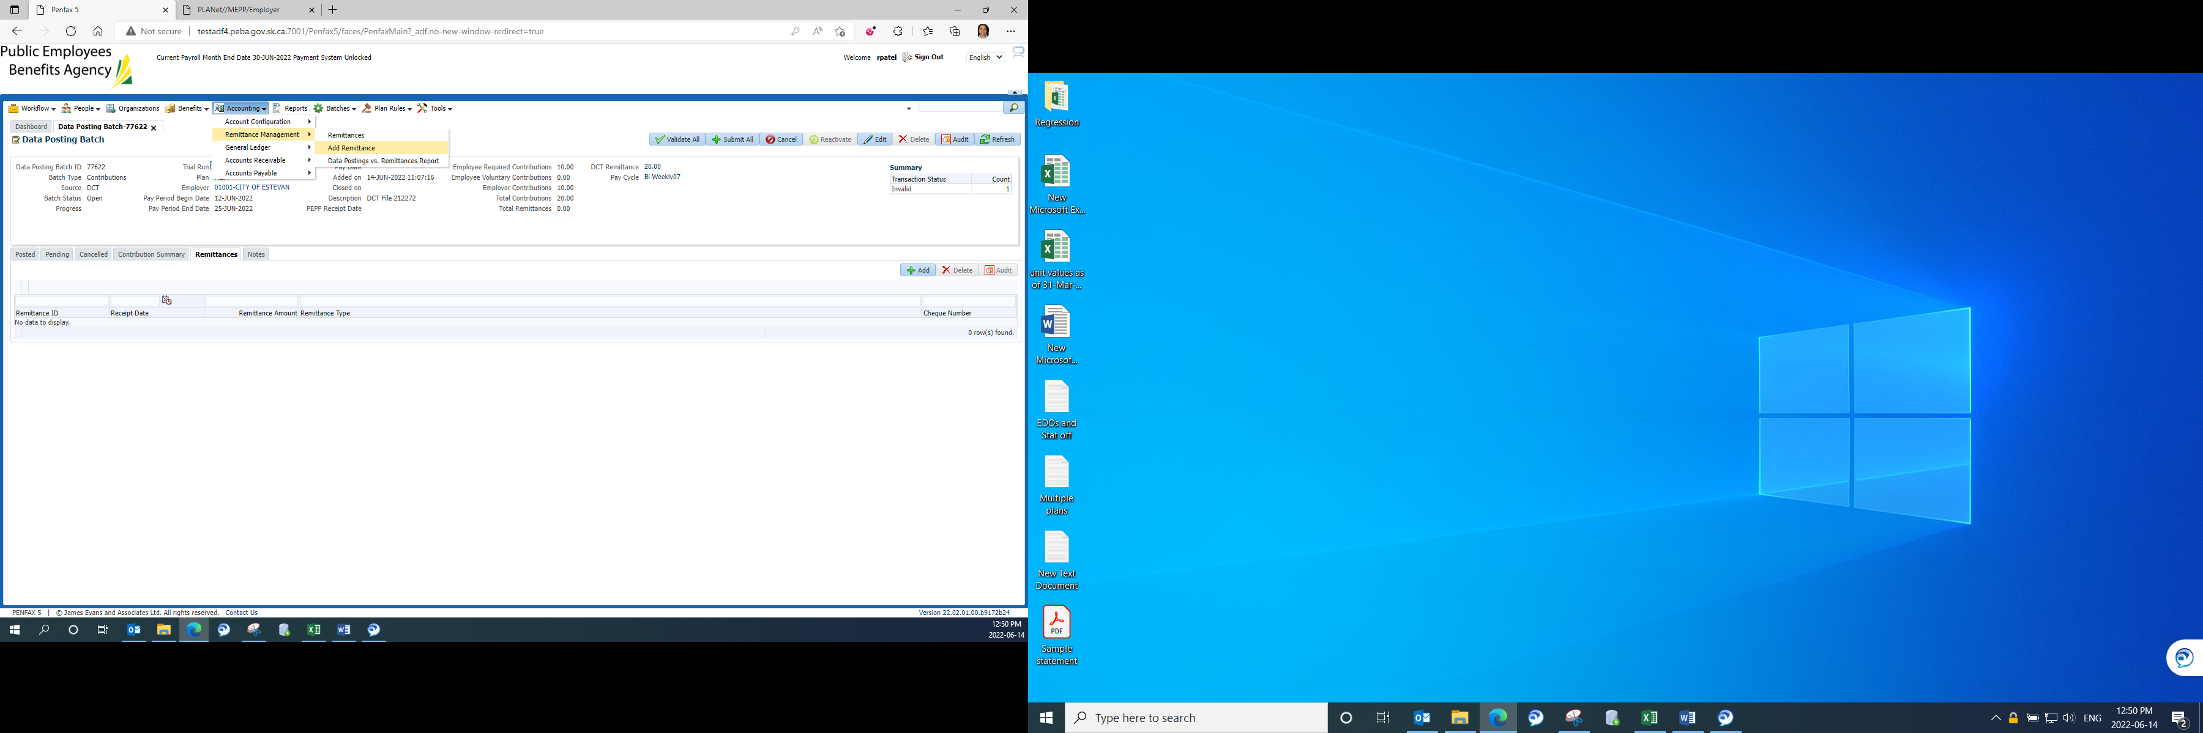

1. Input all the required details and save it.

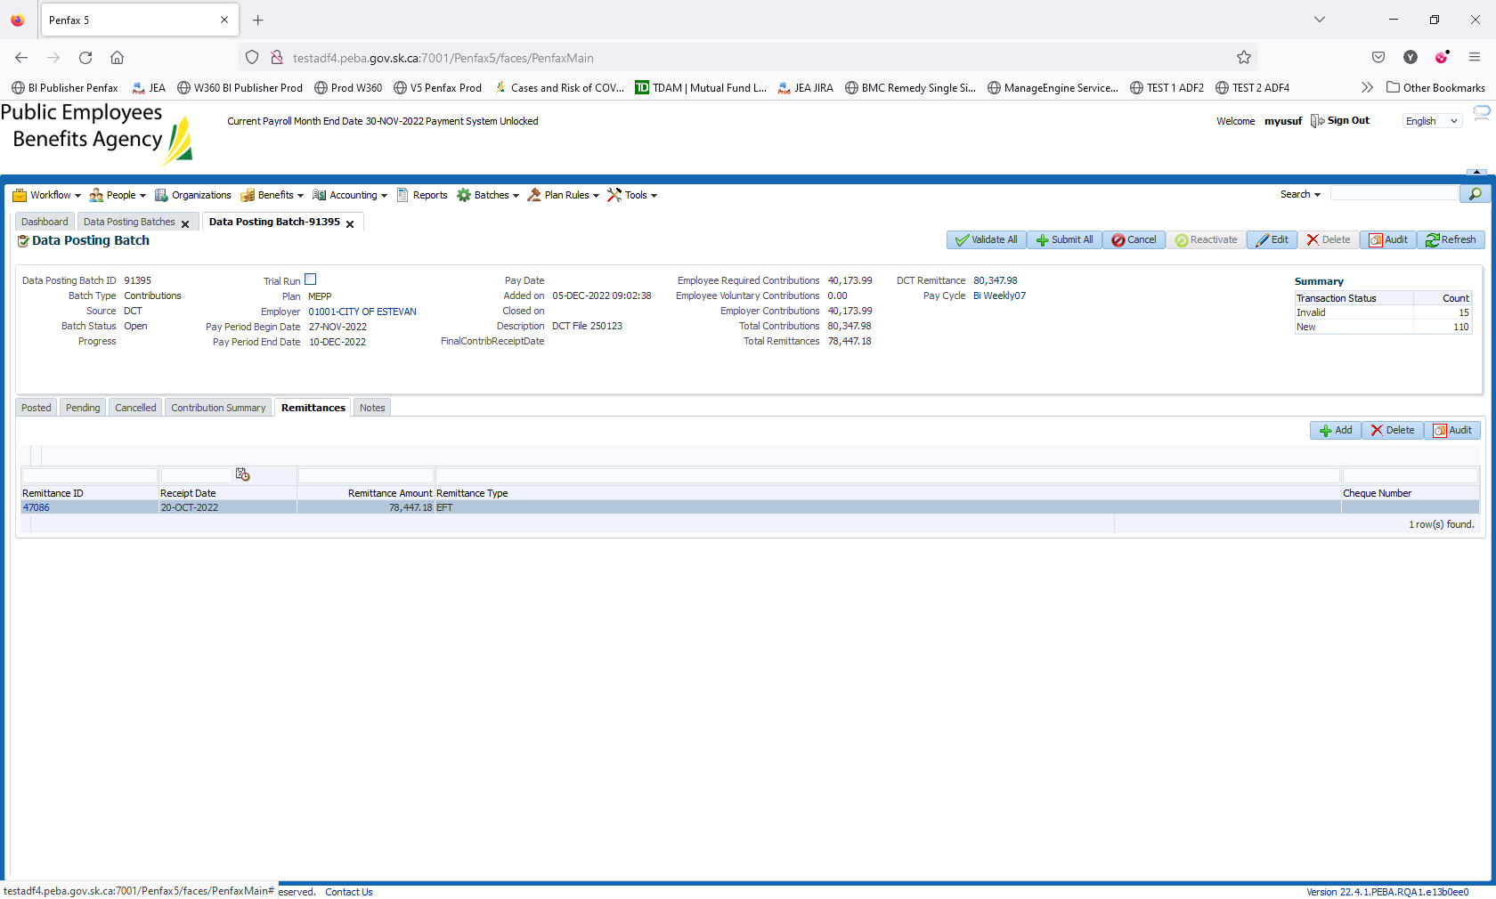

1. Remittance ID 47086 has been created.

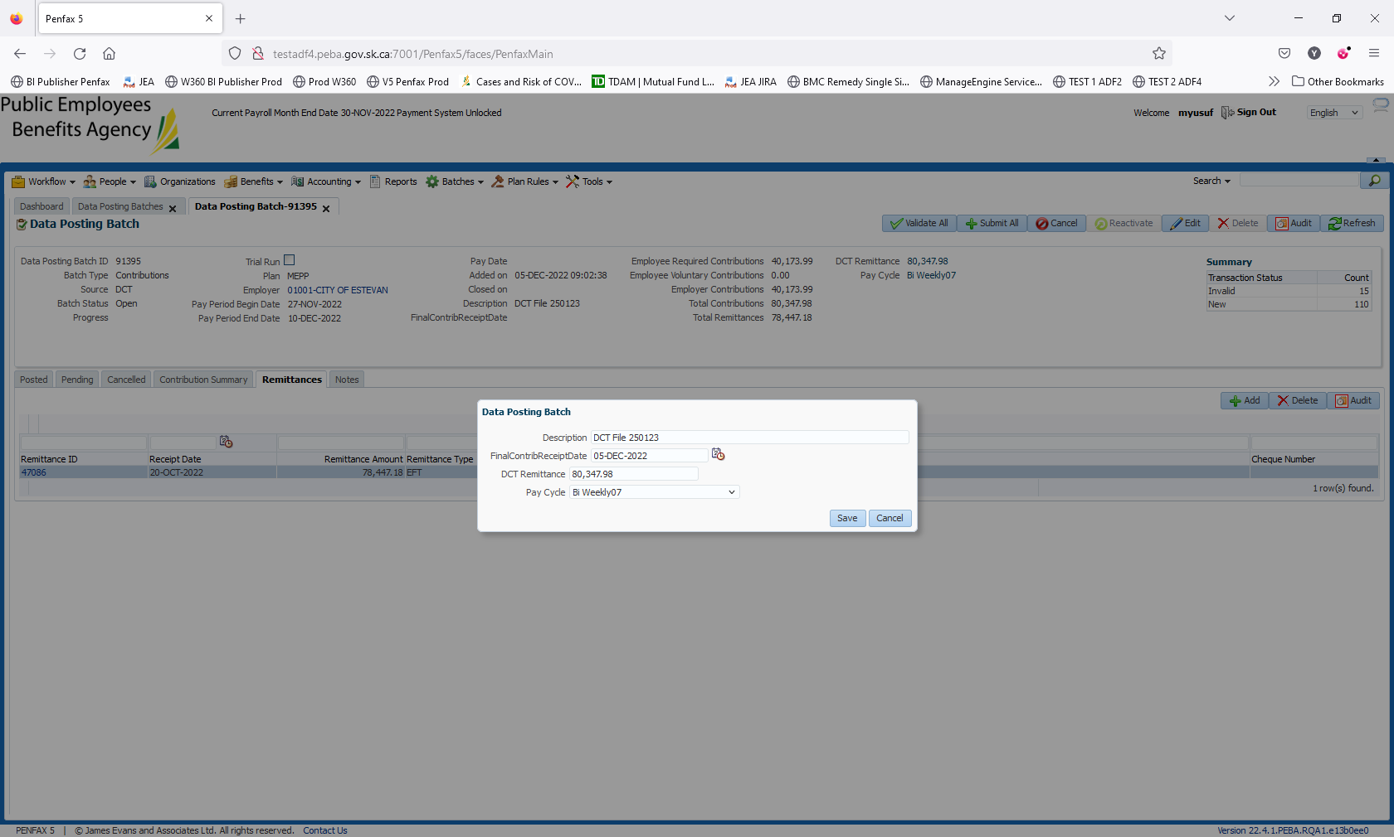

1. Now, go to Data Posting Batch -> Remittance tab and link the remittance you just created.

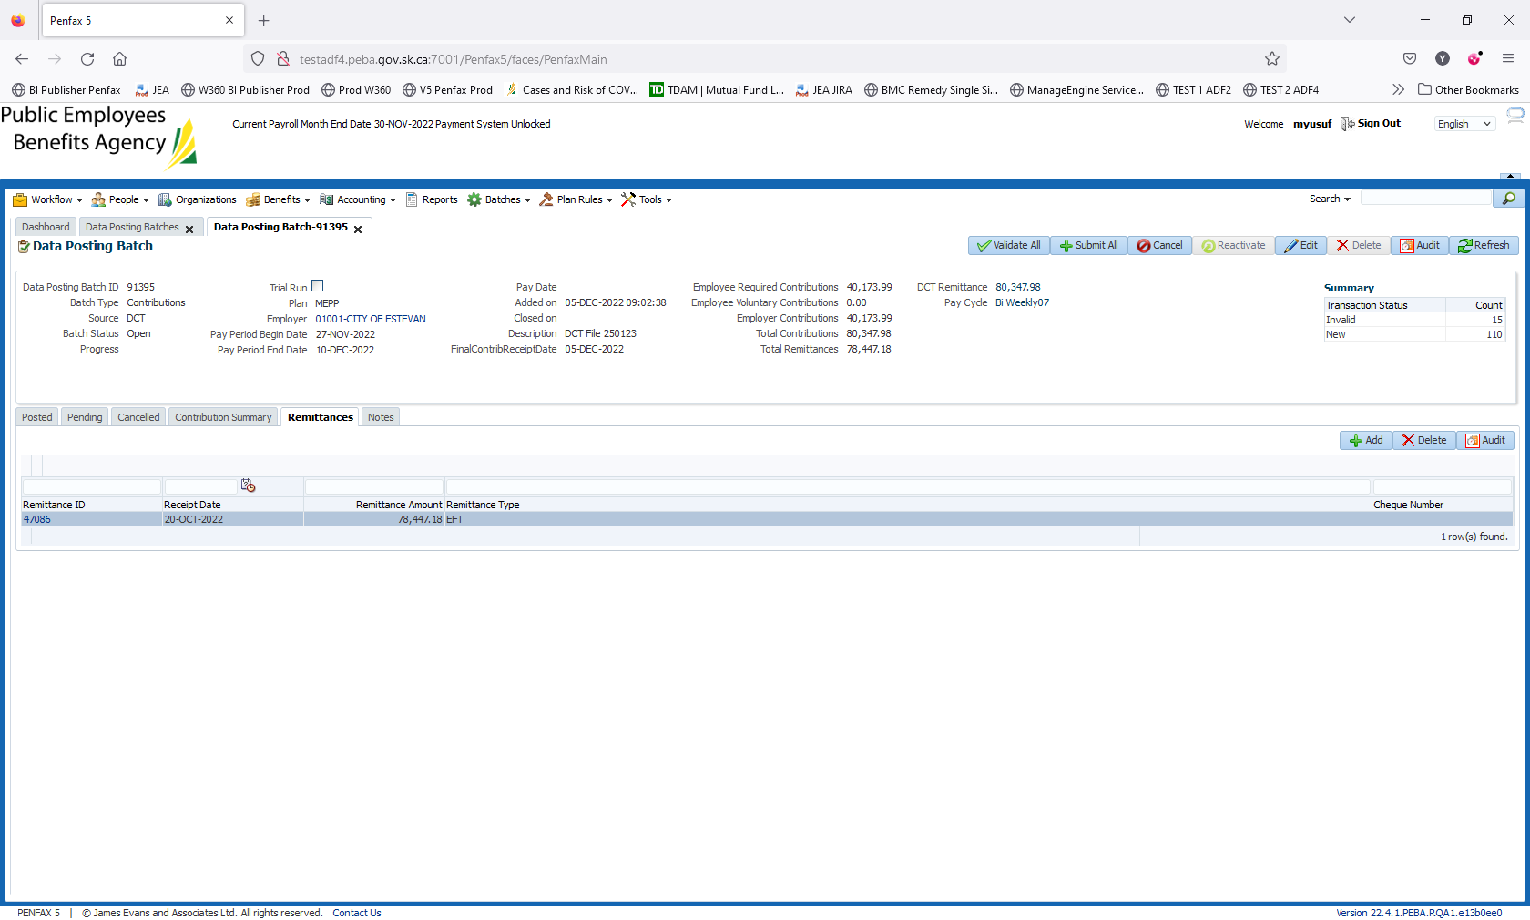

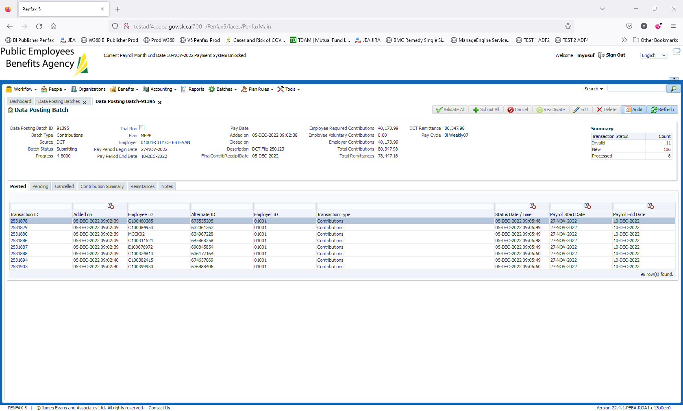

1. Go back to Remittance and you can see the data posting batch ID to which you have linked this remittance.

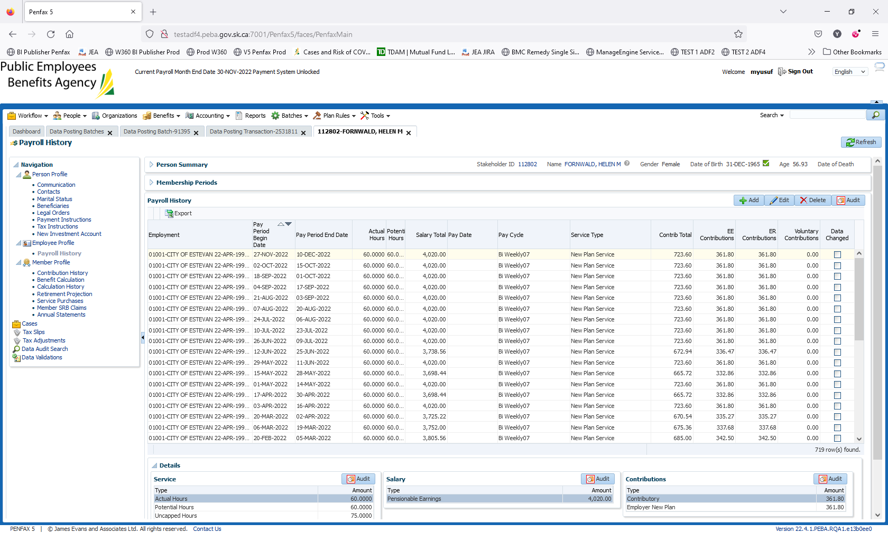

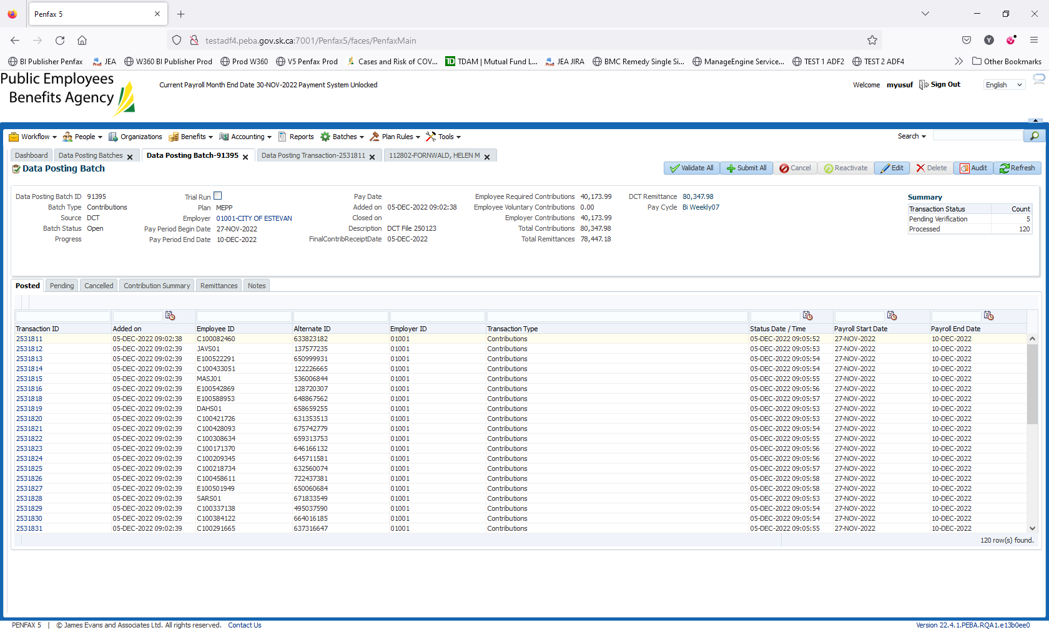

5 members missed out due to the error “Calculated salary results into an amount greater than $100 an hour” Generally fixed by MEPP PIO

1. Go to a Posted tab in Data Posting Batch. To ensure the details have been processed successfully.